Test Educat Modul Class room

Tester : M Munir

Tanggal : 7 Des 2020

1. Source code test_classroom_common.py

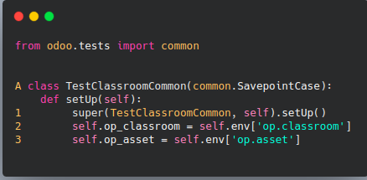

test_classroom.py

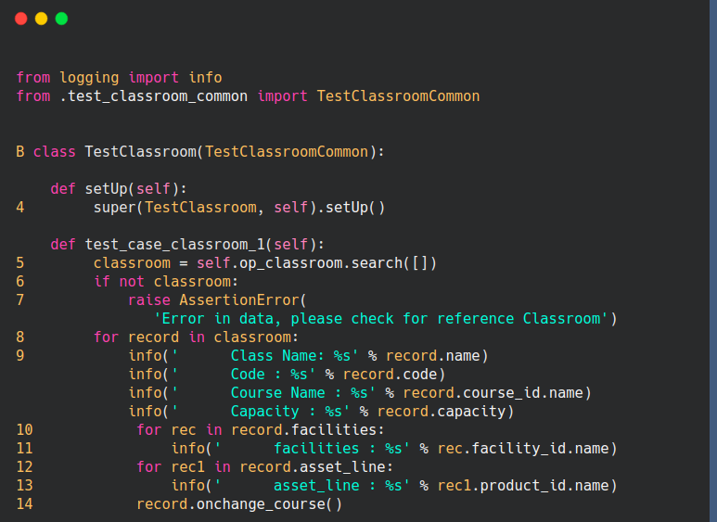

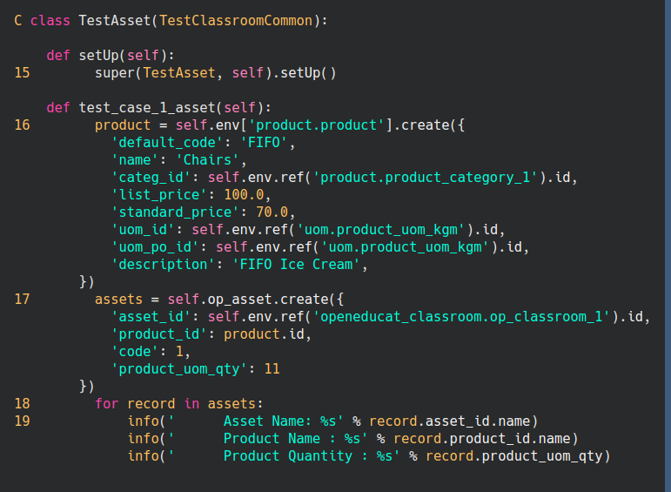

1. Flowgraph

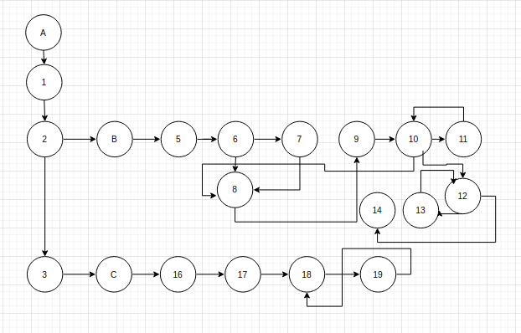

1. Cyclometic Complex

V(G) = E - N + 2

= 24- 20+ 2

= 6

1. Test CASE

|  |  |  |  |
| --- | --- | --- | --- |
| No | Data Uji | Keluaran Yang Diharapkan | Hasil Uji |
| 1 | Class Name: TEST | Pencarian data klas room | valid |
| Code : BB |
| Course Name : AA |
| Capacity : 2 |
| facilities : UH |
| asset_line : HEM |
| 2 | default_code = FIFO | Memasukan asset produk | valid |
| name = Chairs |
| list_price = 100.0 |
| standard_price = 70.0 |
| uom_id = d |
| uom_po_id = f |
| description = FIFO Ice Cream |

1. FlowGraph

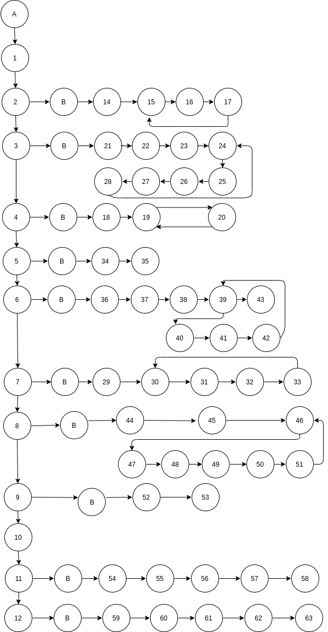

1. Cyclometic Complex

V(G) = E - N + 2

= 81 - 75 + 2

= 8

1. Test Case

|  |  |  |  |
| --- | --- | --- | --- |
| No | Data Uji | Keluaran Yang Diharapkan | Hasil Uji |
| 1 | BOA-S1 | Menemukan data batch yg dicari | valid |
| 2 | TEST | Menemukan data course | valid |
| 3 | first_name = binapshah | Insert data to fakultas | valid |
| last_name = kalol |
| birth_date = 2009-01-01 |
| gender = male |
| 4 | munir | menemukan data pegawai | valid |
| 5 | pt nakula sadewa | menemukan perusahaan user lalu menyimpan data user |  |
| 6 | first_name = nikul | mencari data student | valid |
| middle_name = m | menyimapan data student |
| last_name= ahir |
| birth_date =1999-01-01 |
| gender = m |
| 7 | test | Regrisatrasi kursus | valid |
| 8 | update | menerima notiifkasi | valid |
| 9 |  | menampikan data fakultas ids | valid |
| 10 |  | menampilan data user menurut ids | valid |